You received the topic: IoT in Industry for IoT research-based projects. You have to create a PowerPoint file and explain an IoT project in this domain (such as production line control, system maintenance, or factory monitoring, excluding retail, healthcare, and warehouse management).

Students should select a real project with all the details (not only general information about technology).
A real project means a project completed with a project owner and a contractor. You have to indicate who the project owner is, why they started this project, and who did the project.
The real project means how an IoT solution solved a problem in a factory or industrial sector.
The file should contain the following information:

1- Introduction of the company or organization that implemented the project
Ugreen is a Chinese company that focuses on electronics founded in 2012, where its headquarters are at Shenzen. Ugreen started off as a cable manufacturer, but they eventually expanded out to other technologies and have eventually become a global provider in charging, connectivity solutions, and NAS systems. Ugreen have also become popular with their network-attached hard drives and storage systems, with a big part being the valure for money.
2- What was the problem or the reason for defining this project?
Finding a way to integrate and unifying IoT features into a a single device:
- Security cameras -> one application
- Photos/files → NAS or cloud storage
- Smart lights → another application
- Voice assistant → another service
- Home automation → another platform
- AI processing → often cloud-based
Ugreen is also trying to solve two important technical problems:
Privacy
Photos, camera footage, and other home data sent to the cloud doesn’t necessarily at home. Ugreen tries solving this problem with local storage and local AI processing
Lack of context
Smart home commands require specific sentences for them to be executed:
“Turn on the living room light”
Ugreen solves this problem by making the system understand natural language and context.
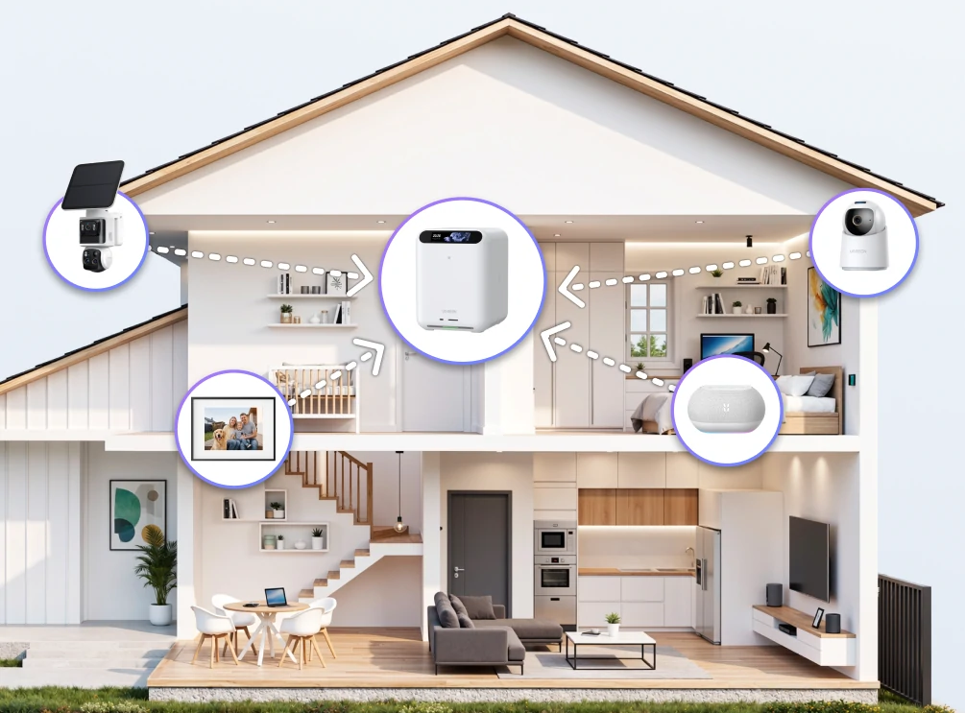
3- The problem, solution, and project implementation steps (technologies, devices, applications, duration, etc.)
Hardware
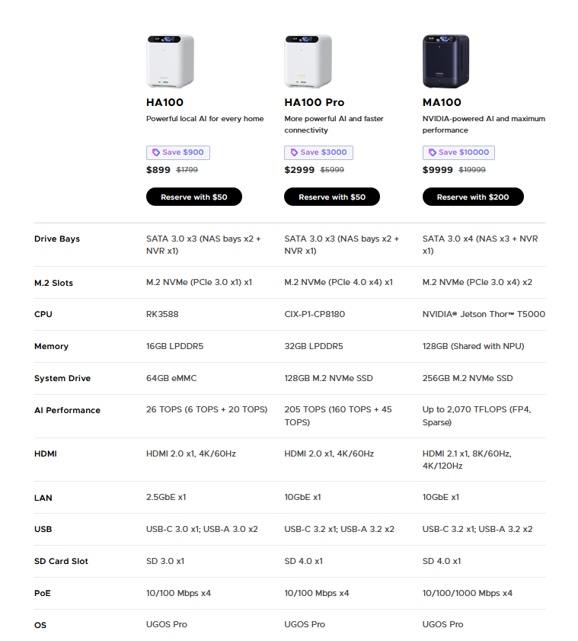
SynCare Cameras
UGREEN Smart Speaker
UGREEN Gallery

Local AI
Each HomeAgent has a dedicated AI that doesn’t send any data to a remote server.
https://cdn.shopify.com/videos/c/o/v/55323d3457d94ef284eb8e08421c8950.webm
https://cdn.shopify.com/videos/c/o/v/2766b7fccd144514852769f7e4b526af.webm
https://cdn.shopify.com/videos/c/o/v/4d338a976880410891ba9e8428717ee1.webm
https://cdn.shopify.com/videos/c/o/v/f48ec961994c4b499187d965ca2e728d.webm
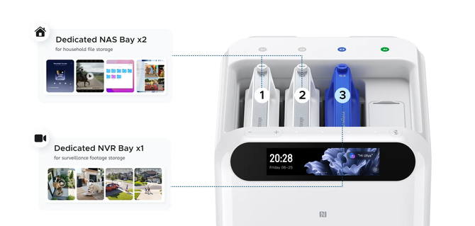
UGREEN Created Uliya as their AI Assistant. Able to understand natural language such as “Uliya, it’s getting dark”, which then triggers the lights and close the curtains. Runs on a local LLM built around Qwen3
4- The results or modifications after finishing the project.

https://ai.ugreen.com/blogs/news/ugreen-smart-living-launch-event-homeagent
https://matter-smarthome.de/en/products/ugreen-a-new-player-in-the-matter-arena/
https://www.notebookcheck.net/Your-Smart-Home-Has-Plenty-of-Devices-What-It-Lacks-Is-a-Brain.1396870.0.html
https://ai.ugreen.com/pages/ugreen-homeagent-crowdfunding?utm_source=chatgpt.com

